~Asia-Japan-Mirror-Shan-Edo

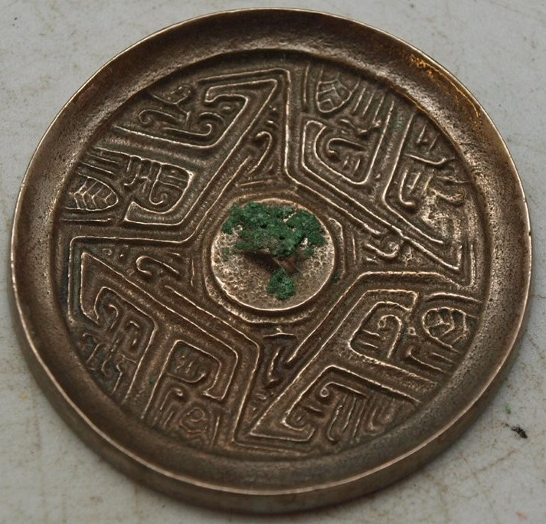

Stunning bronze Japanese mirror measuring 37mm in diameter.  This bronze mirror is silver plated, but has been heavily tarnished.  The back is decorated with primitive scenes.  It has a central boss which is pierced to allow a cord to be passed through for holding.  The other side is undecorated and would have originally been polished to create a reflective surface.